The idea of inheritance is simple but powerful: When you want to create a new class and there is already a class that includes some of the code that you want, you can derive your new class from the existing class. In doing this, you can reuse the fields and methods of the existing class without having to write (and debug!) them yourself.

A subclass inherits all the members (fields, methods, and nested classes) from its superclass. Constructors are not members, so they are not inherited by subclasses, but the constructor of the superclass can be invoked from the subclass.

The Object class, defined in the java.lang package, defines and implements behavior common to all classes—including the ones that you write. Class Object is the root of the class hierarchy. Every class has Object as a superclass.

Terminology

Super Class- Superclass is a class whose properties and behavior are used by the child class.

Sub Class- Subclass is a class that inherits the properties of another class.

Reusability- Inheritance allows the reuse of code. When we create a new class and there is already a class that includes some common properties or feature that a class has to write. It can be driven to the new class from the existing class by reusing the field and method.

When an object to Bike, Car, and Truck class is created, a copy of the contents of the superclass (Vehicle) is made within it. That is why using the object of the subclass you can access the members of a superclass.

Example 1:

class SuperClass {

public SuperClass() {

System.out.println("Super Class");

}

public SuperClass(String name) {

System.out.println("SuperClass: Hello " + name);

}

int superN;

public void disp() {

System.out.println(superN);

}

}

class SubClass extends SuperClass {

public SubClass() {

super("Kerry");

System.out.println("Sub Class");

}

public void input() {

superN = 60;

}

}

public class Test {

public static void main(String[] args) {

SubClass sub = new SubClass();

sub.input();

sub.disp();

}

}

Example 2:
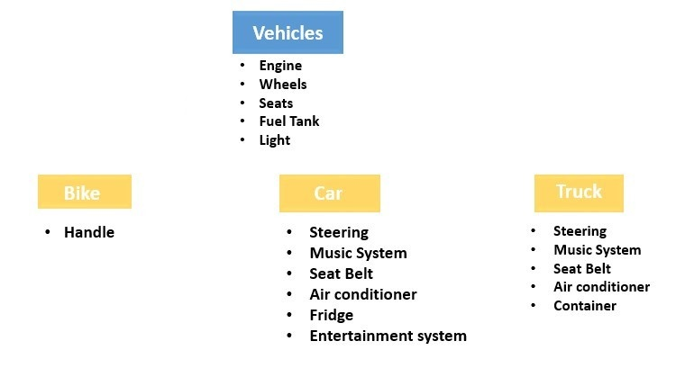

Extend Keyword

Extend keyword is used to inherit the properties of the class.

Let us consider the following program that demonstrates that inherits some properties and methods in child class from the parent class.

Step 1: Let us create a class vehicle where we declare and define common properties and methods. Here, vehicle is a super-class.

public class Vehicle {

public String engine;

public int wheels;

public int seats;

public int fueTank;

public String lights;

}
Step 2: We create a child class for example Bike, Car, Truck class which extends the above class Vehicle. Here all these classes use specific properties. You can observe these specific properties in blow statement.

Bike class

public class Bike extends Vehicle {

public String handle;

}

Car class

public class Car extends Vehicle {

public String steering;

public String musicSystem;

public String airConditioner;

public String fridge;

public String entertainmentSystem;

}

Truck class

public class Truck extends Vehicle {

public String steering;

public String musicsystem;

public String airConditioner;

public String container;

}
Step 3: We create a class called Demo for creating an object of Bike class and initialize the variable with string “short”.

public class Demo {

public static void main(String[] args) {

Bike bike = new Bike();

bike.handle = "short";

}
Step 4: We can access the methods from super-class in the sub-class as if they are in the same class. e.g We create an object of bike class, which access the engine property of vehicle class.

public class Demo {

public static void main(String[] args) {

Bike bike = new Bike();

bike.handle = "short";

bike.engine = "Petrol";

System.out.println(bike.engine);

}

}

Output: Petrol

Example 1:

class Vehicle {

public String engine;

public int wheels;

public int seats;

public int fueTank;

public String lights;

}

class Bike extends Vehicle {

public String handle;

}

class Car extends Vehicle {

public String steering;

public String musicSystem;

public String airConditioner;

public String fridge;

public String entertainmentSystem;

}

class Truck extends Vehicle {

public String steering;

public String musicsystem;

public String airConditioner;

public String container;

}

public class Test {

public static void main(String[] args) {

Bike bike = new Bike();

bike.handle = "short";

bike.engine = "Petrol";

System.out.println(bike.engine);

}

}

What You Can Do in a Subclass
A subclass inherits all of the public and protected members of its parent, no matter what package the subclass is in. If the subclass is in the same package as its parent. You can use the inherited members as is, replace them, hide them, or supplement them with new members:

The inherited fields can be used directly, just like any other fields.

You can declare a field in the subclass with the same name as the one in the superclass, thus hiding it (not recommended).

You can declare new fields in the subclass that are not in the superclass.

The inherited methods can be used directly as they are.

You can write a new instance method in the subclass that has the same signature as the one in the superclass, thus overriding it.

You can write a new static method in the subclass that has the same signature as the one in the superclass, thus hiding it.

You can declare new methods in the subclass that are not in the superclass.

You can write a subclass constructor that invokes the constructor of the superclass, either implicitly or by using the keyword super.
Private Members in a Superclass
A subclass does not inherit the private members of its parent class. However, if the superclass has public or protected methods for accessing its private fields, these can also be used by the subclass.
A nested class has access to all the private members of its enclosing class—both fields and methods. Therefore, a public or protected nested class inherited by a subclass has indirect access to all of the private members of the superclass.
Casting Objects
Let’s take an example to understand the casting objects:

class Bicycle {

}

class MountainBike extends Bicycle {

}
For example, if we write

public MountainBike myBike = new MountainBike();
then myBike is of type MountainBike.
MountainBike is descended from Bicycle and Object. Therefore, a MountainBike is a Bicycle and is also an Object, and it can be used wherever Bicycle or Object objects are called for.
The reverse is not necessarily true: a Bicycle may be a MountainBike, but it isn't necessarily. Similarly, an Object may be a Bicycle or a MountainBike, but it isn't necessarily.
Casting shows the use of an object of one type in place of another type, among the objects permitted by inheritance and implementations. For example, if we write

Object obj = new MountainBike();
then obj is both an Object and a MountainBike (until such time as obj is assigned another object that is not a MountainBike). This is called implicit casting.
If, on the other hand, we write
MountainBike myBike = obj;
We would get a compile-time error because obj is not known to the compiler to be a MountainBike. However, we can tell the compiler that we promise to assign a MountainBike to obj by explicit casting:
MountainBike myBike = (MountainBike)obj;
This cast inserts a runtime check that obj is assigned a MountainBike so that the compiler can safely assume that obj is a MountainBike. If obj is not a MountainBike at runtime, an exception will be thrown.
Note: You can make a logical test as to the type of a particular object using the instanceof operator. This can save you from a runtime error owing to an improper cast. For example:
if (obj instanceof MountainBike) {
MountainBike myBike = (MountainBike)obj;
}
Here the instanceof operator verifies that obj refers to a MountainBike so that we can make the cast with knowledge that there will be no runtime exception thrown.

Example 2:

class Bicycle {

public int speed;

}

class MountainBike extends Bicycle {

public int seatHeight;

public void setValues() {

speed = 25;

seatHeight = 20;

}

public void disp() {

System.out.println("Speed: " + speed + ", Seat Height: " + seatHeight);

}

@Override

public String toString() {

return "MountainBike [seatHeight=" + seatHeight + ", Speed: " + speed + "]";

}

}

public class Test {

public static void main(String[] args) {

Object obj = new MountainBike();

// System.out.println(obj.setValues());//Error: The method setValues() is undefined for // the type Object

System.out.println(obj.toString());

MountainBike myBike = null;

// Error: Type mismatch: cannot convert from Object to MountainBike

// myBike = obj;

// Explicit casting but if obj is not a MountainBike at runtime, an exception will be thrown.

// myBike = (MountainBike) obj;

if (obj instanceof MountainBike) {

myBike = (MountainBike) obj;

}

myBike.setValues();

myBike.disp();

System.out.println(myBike.toString());

}

}

